CTM-I Use Case

Edit User

Version 0.1

Use Case Name | Edit User
Actor | Firm User, Market Ops, Ops, App Support
Pre-conditions /Assumptions | User selected a user to edit on the User Maintenance screen.
Post Conditions | User can return to the User Maintenance screen by pressing the “Return to User Maintenance” link.
Screenshot | 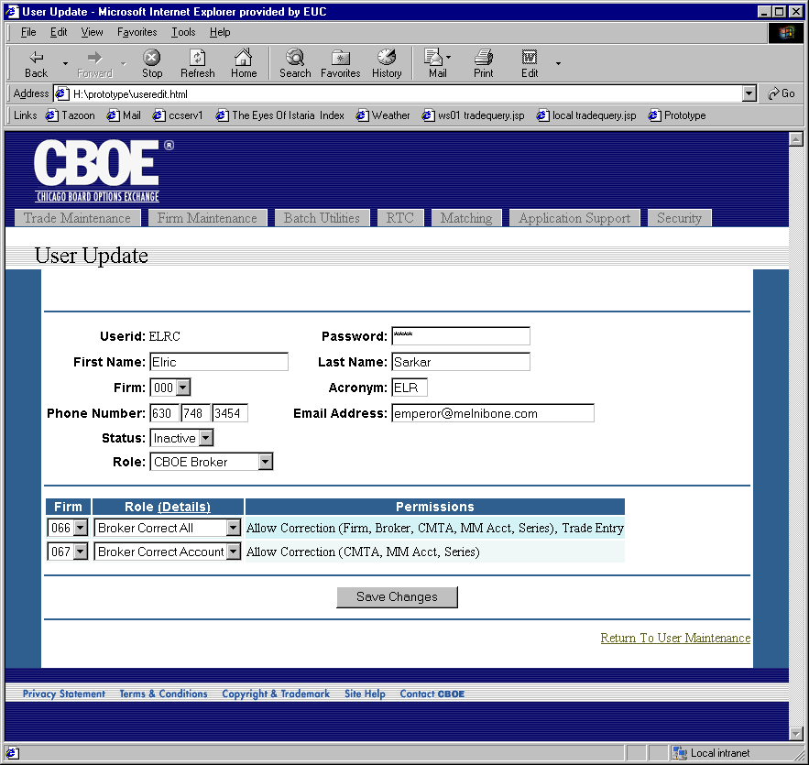
Flow of Events | - User selects a user to edit from the User Maintenance User Case.  - A request is sent to the Security Service to get the user data.  - If the role is CBOE Broker, a request is sent to CTM-R to get the relationships between the user and their firm roles.  - User Maintenance screen appears. All the fields on the screen are pre-populated with the data for the user selected.  - The screen is split into two sections. The top section is the user security information. The bottom section is the broker roles by firm.  - The user security information is only editable if the user has permissions to edit the users for the firm of the user being edited.  - The broker roles by firm is only available if the user being edited has a role of CBOE Broker.  - The following fields are displayed in the user security information section.  - Userid - Not Editable  - Password.  - First Name  - Last Name  - Role – Role selection is limited by the user. The user cannot select a role that has more permissions than they have.  - A firm user can only add users with firm roles.  - A market ops user can add users with broker, firm and market ops roles.  - An operations user can add users with broker, firm, market ops and ops roles.  - An app support user can add any role.  - Firm - Select from a list of firms available to the user.  - Acronym – Acronym is validated to ensure the acronym is a valid acronym.  - Phone Number – Basic phone number validation should be done.  - Email Address – Basic email address validation should be done.  - Status (Active, or Inactive)  - The Broker Roles by Firm section is displayed in a table format. Each row of the table shows a firm and what permissions the user has for that firm. The user is only allowed to see and edit the firms the user has permissions to administer.  - The columns in the table for Broker Roles by Firm are:  - Firm – Firm is limited to the firms the user can set permissions for.  - Role – Role is limited to the list of broker roles for a broker. Clicking the “Details” link on the header row can access a detail of each role and the permissions it enables.  - Permissions – A display only field to show a summary of the permissions for the selected role. When the role is changed, the text in this field should change to reflect the broker role.
Alternative Path | - After performing a search, the user can refresh the data at any time by pressing the search button.  - Search Criteria and current page information will be available to other pages to return to the current search results.

